

School of Commerce

**NSS CAMP**

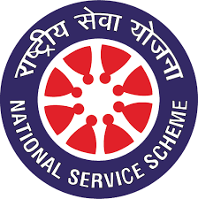

**(National service Scheme)**

**Duration:** 25th February 2019 TO 03rd March 2019

**Place:** Mylana Halli, Bangalore-560064

The NSS camp was Organized by the Central NSS Committee of REVA University in the month of February and March 2019. The following students represented the School of Commerce in the Camp. The list of students is as under:

**Number of Students Attended**

|  |  |  |  |  |
| --- | --- | --- | --- | --- |
| **S.I.No** | **SRN** | **Student Name** | **Program** | **Semester** |
| 1 | R18BC114 | Rohith-S | B COM | II (B-Section) |
| 2 | R18BC117 | Rakshith Kumar | B COM | II (B-Section) |
| 3 | R17BC026 | Bhavana Ashok | B COM | IV (A-Section) |
| 4 | R17BC044 | Ganguly | B COM | IV (A-Section) |
| 5 | R17BC152 | Shravani | B COM | IV (C-Section) |
| 6 | R17BC156 | Sandeep | B COM | IV (C-Section) |
| 7 | R17BC157 | Sandhya | B COM | IV (C-Section) |
| 8 | R17BC164 | Shirly | B COM | IV (C-Section) |
| 9 | R16BC095 | Mehul Ishwar Lal | B COM | IV (B-Section) |
| 10 | R16BC033 | Dhanush | B COM | VI (A-Section) |